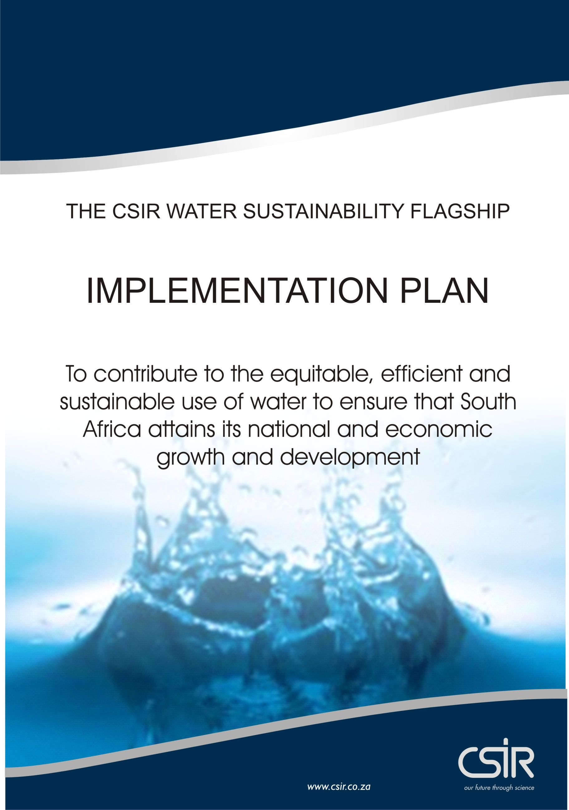
EXECUTIVE SUMMARY

EXECUTIVE SUMMARY

Contents

1.0 FLAGSHIP SCOPE AND PROBLEM STATEMENT 3
2.0 OBJECTIVES AND GOALS 8
3.0 EXPECTED RESULTS 10
4.0 APPROACH 10
5.0 THE PROJECT DESCRIPTION 11
6.0 COMPONENTS OF THE INTEGRATED SOLUTION 14
7.0 PROJECT DETAIL 15
8.0 MEASURABLES (YEAR 1) 16
9.0 FINANCIALS 22

Version 2: 08-06-2012
The full plan and detailed work description is available on the CSIR Document management System as GWMDS # 216950 (PTA GEN)
1.0 FLAGSHIP SCOPE AND PROBLEM STATEMENT
Water challenges in South Africa are well known and documented (e.g. DEAT, 2006; 2030 Water Resources Group, 2009; CSIR, 2010; DWA, 2011). The most significant challenges include increasing water scarcity, poor and ageing infrastructure, skills and capacity shortages in the water sector, increasing pollution, failure to meet environmental flow requirements, poor enforcement of regulations and potential impacts of a changing climate.

Given that water is a crucial, cross-sectoral input for all development and growth, its availability (and quality) will be a limiting factor across the country. Many initiatives to address these challenges have been taken up in the different sectors, though these have been fragmented and isolated often resulting in ineffective solutions at the national level. These include (1) The Department of Water Affairs (DWA) Water for Growth and Development (WfGD) Framework (January 2009) and (2) the (draft) DWA National Water Resources Strategy (NWRS II) (DWA, 2011)

The WfGD represents DWA’s strategic turnaround approach in managing the country’s water more effectively and efficiently in order to enhance economic and development goals as well as to respond to concerns raised regarding the state of water in the country over the past two years. These concerns include that South Africa will experience severe water shortages by 2025; Gauteng will run out of water in 2013; the state of South Africa’s water resources infrastructure (i.e. dams) is in a poor condition; South Africa’s rivers are severely polluted; and that municipal infrastructure (in particular waste water treatment plants) are failing, the latter having an added effect on the state of the rivers. A further concern highlighted is the lack of skills and capacity at various technical and managerial levels within the water sector.The WfGD Framework is responsive to the needs of various economic sectors and points to the relationship between water availability and the forms of economic activity that are dependent on available water supply of varying levels of quantity and quality depending on the technologies being used.

The (draft) National Water Resources Strategy (NWRS II) (DWA, 2011), identifies four challenges in the water perspective for South Africa, namely (1) Water underpins the socio-economic development of SA, (2) water resources in SA are limited and under stress, (3) SA’s future depends on timely resource planning, and (4) SA strives to be a responsible neighbour and global player. It lists three main water concerns which are associated with three of the challenges. These are: (A) decreasing water security; (B) deterioration of ecosystems; and (C) deterioration of water & wastewater infrastructure.

In September 2008 the Minister of Water Affairs introduced a regulatory approach that has gained significant momentum as an Incentive-based Regulation. Two programmes, the Blue Drop Certification Programme for Drinking Water Quality Management Regulation and the Green Drop Certification Programme for Wastewater Quality Management Regulation define the concept.

The Green Drop process measures and compares the results of the performance of Water Service Authorities and their providers, and subsequently rewards (or penalises) the municipality upon evidence of their excellence (or failures) according to the minimum standards or requirements as defined. Awareness of this performance is obtained by pressure through the customers, the media, political classes and NGOs. The strategy revolves around the identification of mediocre performing municipalities who consequently correct the identified shortcomings, as well as the introduction of competitiveness amongst the municipalities and using benchmarking in a market where competition is difficult to implement.

Water Quality

A key conclusion from the Green Drop Certification Programme showed that many of South Africa’s waste water collection and treatment systems are failing. This impacts directly onto the water quality in the water resource system.

Waste water treatment occurs via one or more natural systems (i.e. wetlands, natural side-channel vegetation, sand or soil filters and in-stream reedbed systems), the so-called ecosystem services. Man-made waste water treatment works take on many forms with the conventional municipal works typically consisting of a combination of components including anaerobic digester technology.

The 2011 Green Drop Report (DWA, 2011) shows that the Green Drop Certification programme of 2010/11 verified the status of wastewater service delivery by hundred and fifty-six (156) municipalities that provide services via an infrastructure network comprising of 821 wastewater collector and treatment systems. Statistics taken from the DWA, (2011) report are summarised in the figure below and show that a significant number of the waste water collector and treatment systems did not reach the compliance threshold of above 50%. The Free State, Northern Cape and Limpopo Provinces have the largest challenges. 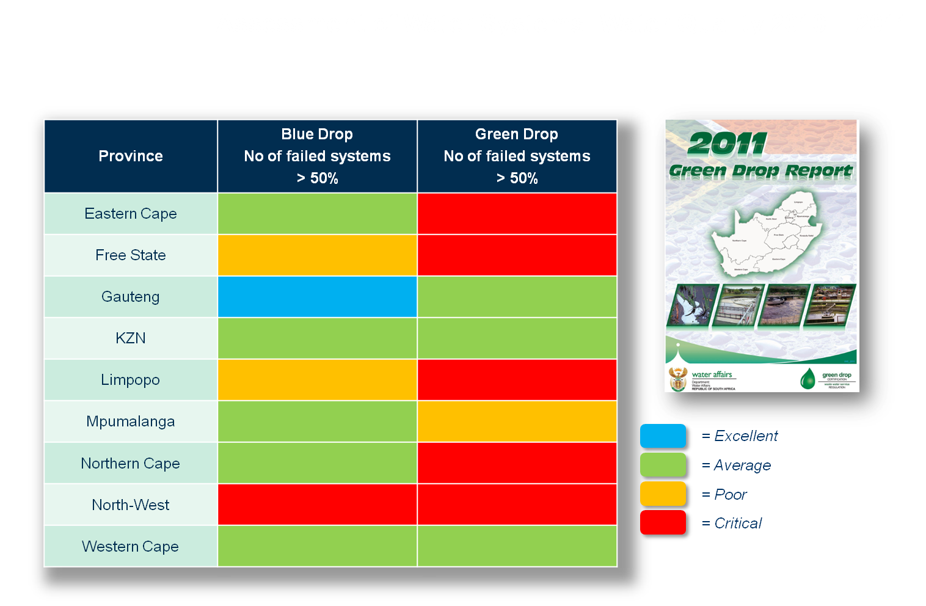
Green Drop Status: Water and waste treatment during 2010 – 2011
http://www.ewisa.co.za/misc/BLUE_GREENDROPREPORT/GreenDrop2011.htm

The Cumulative Risk Rating (CRR) included in the report provides a risk analysis that focuses on the wastewater treatment function specifically. It provides insight into the treatment component of the total municipal waste water management value chain. This component is one of the high risk components within the production chain and allows the municipality to identify and prioritise the critical risk areas within its wastewater treatment process and to take corrective measures to abate these. The results for 2011 show that the biggest deviation from the maximum value (CRR_{max}) that the deviation can reach occurs in the Free State, Limpopo and Eastern Cape Provinces with deviation values of 83%, 79% and 78% respectively. The deviation limits that define a critical state are in the range (90-100%).

Problem Statement

The available information therefore indicates that large areas in South Africa experience ‘water stress’ and this situation is likely to continue in future. There are escalating demands for water from a growing population and expanding economy.

The disparity in service delivery provides many challenges associated with the requirement to address this and water is needed to ensure food security and energy security. There is a worsening of water quality in many rivers with a deterioration of reservoirs and ecosystems and especially rural communities face growing risks of water shortages and the health impacts of contamination.

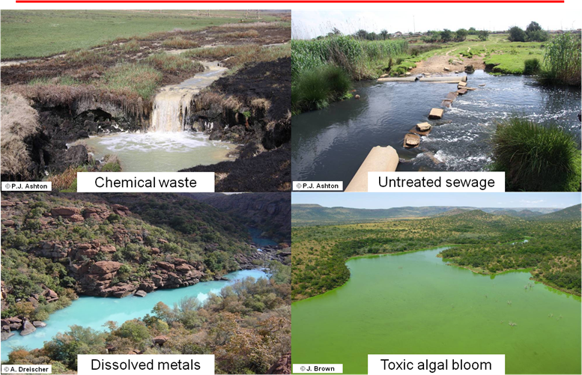

Water quality problems in the Olifants River Basin

As indicated by the Green Drop Report (DWA 2011) and in particular the Cumulative Risk Rating (CRR) assessment, the failure of many urban, peri-urban and rural waste water treatment plants poses a real health threat to downstream populations as well as the functioning of natural resource systems. The figure below depicts the main components of the system and their logical linkages within which the waste water treatment plant forms the central point.

The schematic below is a simplified version of the wider system depicted above within which the problem occurs.
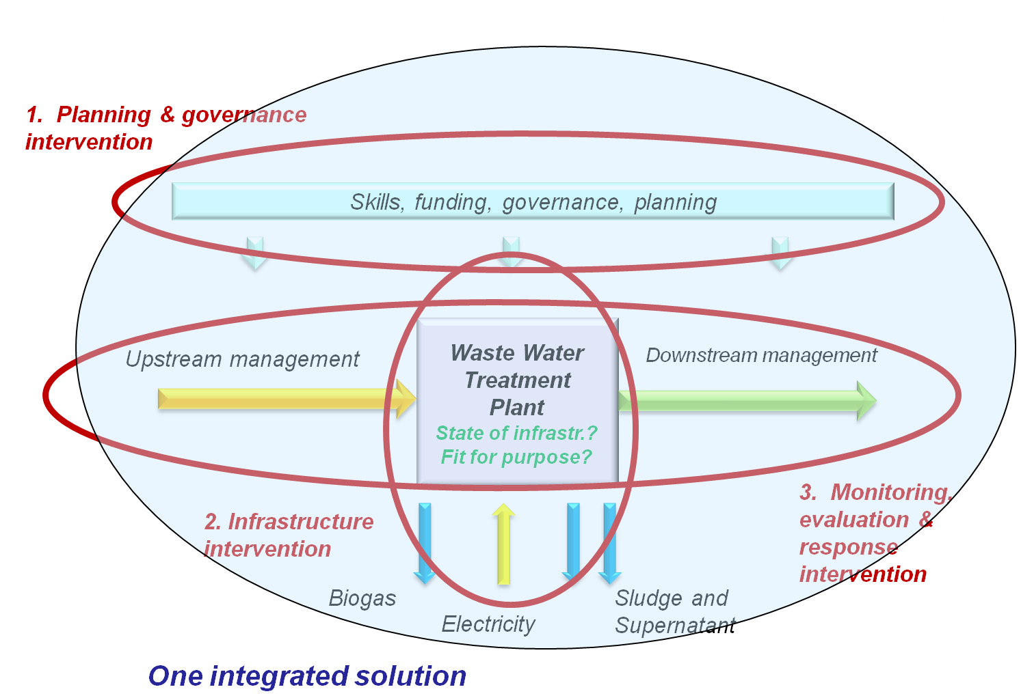

As shown in the figure above, the systems analysis reflects three logical clusters of interlinked ‘Intervention Areas’, each with an associated focusing problem statement defined below:

Planning and Governance in relation to Waste Water Treatment Works
Associated problem statement:
Inadequate strategic, integrated and cooperative governance and planning for water sustainability constrains equitable access as well as sustainable and inclusive development.

Solid waste/sludge treatment & management
Associated problem statement:
Failing sewage treatment works impact on people’s health and water resources.

(Near) real-time monitoring system for Waste Water Treatment Works
Associated problem statement:

The lack of (near) real-time system performance information hampers effective and efficient response

2.0 OBJECTIVES AND GOALS
Given the situation, problems and associated implications described above, the CSIR’s Water Sustainability Flagship (WSF) provides a mechanism to focus the organization’s capabilities and invite collaboration from strategic partners in contributing to solving the country’s water challenges. This provides an opportunity to give effect to the outputs from the CSIR’s R&D activities done under for example the Research Impact Areas (RIAs).

The essence (or overall objective) of the WSF is “to contribute to the equitable, efficient and sustainable use of water to ensure that South Africa attains its national and economic growth and development aspirations.”

The expectation is that, through the WSF, products of research and technological/knowledge development produced by the CSIR will be further developed for implementation within a relatively short time frame and that these will have a positive/noticeable impact on the economy and society.

As reflected in the Logic Model adapted from RAND (www.rand.org) in the figure below, the anticipated output of the WSF is therefore to move beyond simply providing evidence in support of decision-making to a suite of practical and sustainable tools and technologies to assist practitioners and decision makers in the water sector.

Here the objective statement and underpinning strategic programme outcomes are used as the starting points. These reflect the WSF Focus Areas as discussed above.

To realise the desired impact some change has to be induced in the way the targeted stakeholder groupings address their mandated responsibilities. For the WSF these are defined as Intermediate Outcomes reflected in the second column from the right.

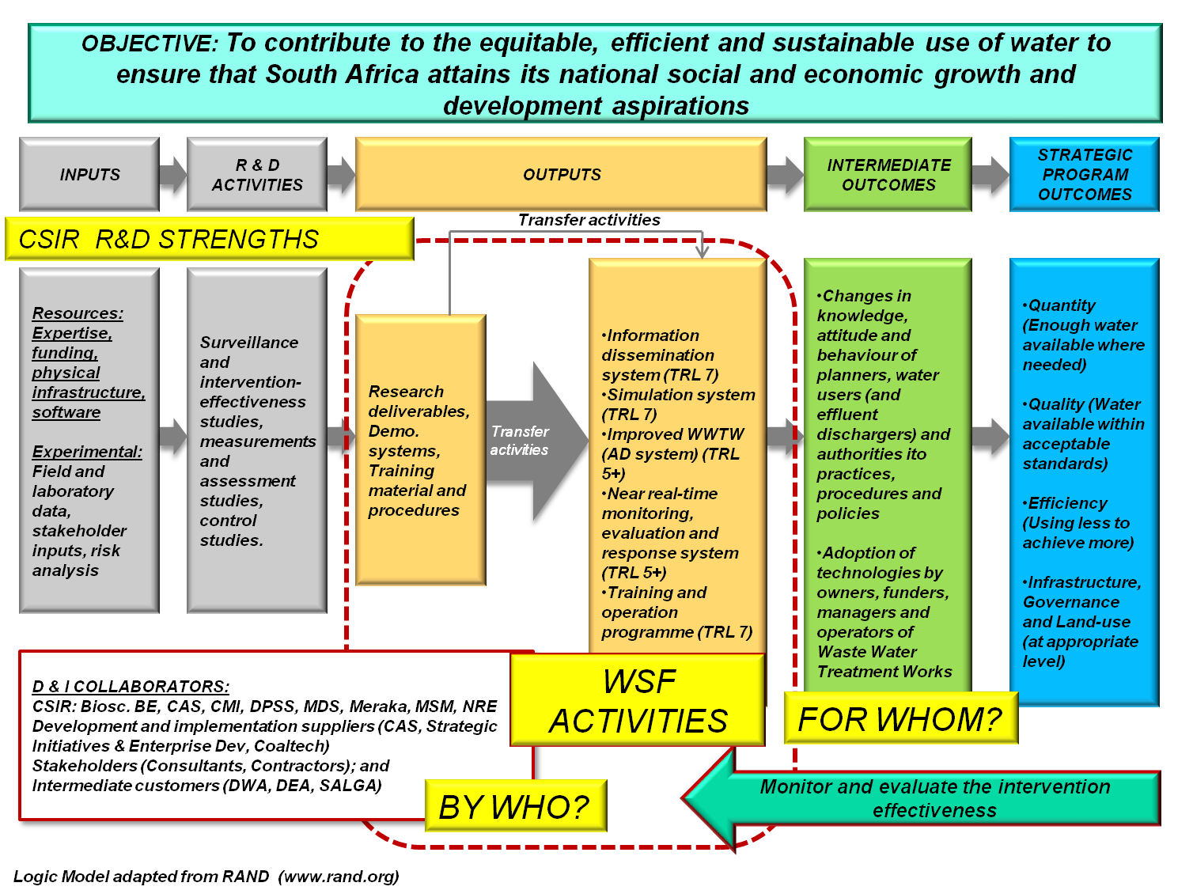

The Outputs of the Development and Implementation (D & I) activities carried out under the WSF are depicted in the central two columns demarcated by the dotted line in the Logic Model diagramme above. Technologies (or ‘tools’) developed by the CSIR that are at a Technology Readiness Level (TRL) above 5 form the basis for the ‘quick win’ D&I activities over the first 12 to 18 month period. As indicated, these activities can only be achieved through effective and efficient collaboration across the capabilities in CSIR and within its external network.

3.0 EXPECTED RESULTS
Although the final end users (or target population) are the ‘People of South Africa’, the various levels of government are mandated to act on behalf of their constituents and to ensure a healthy and safe environment and are therefore seen as the Intermediate Customers.

To this end the South African Government has agreed on 12 outcomes as a key focus of service delivery work up to 2014. Each outcome has a limited number of measureable outputs with targets. For example, the Delivery Agreement for Outcome 10: Environmental Assets and Natural Resources that are valued protected and continually enhanced (www.environment.gov.za) has as Output 1 ‘Enhanced quality and quantity of water resources’ with sub-outputs of (1) water demand management, (2) water resource protection, and (3) regulation of water quality.

Aligned to assist the above, the expected results of the WSF are therefore to (1) facilitate changes in knowledge, attitude and behaviour of planners, water users (and effluent dischargers), and authorities in terms of the implementation of the required practices, procedures and policies that influence water quality, and (2) the adoption of relevant technologies by owners, funders, managers and operators of waste water treatment works in municipalities.

4.0 APPROACH
Two parallel intervention processes are being followed, namely (1) a short-term approach focused on the water quality and efficiency components at Waste Water Treatment Works where the results should be realised within 1 to 2 years, and (2) the bigger picture where water quantity, quality and treatment efficiency at water basin scale are addressed and results realised within 3 to 5 years.

Since the intention of the CSIR Flagship initiative is to develop and implement current CSIR Technology Demonstrators (TRL 5 and above) to at least pilot scale (TRL 7 and above), a process was followed to identify suitable TRL 5+ products within CSIR that aligned with and addressed the needs within the identified Intervention Areas.

The essence of the intervention plan is depicted in the summary figure below.

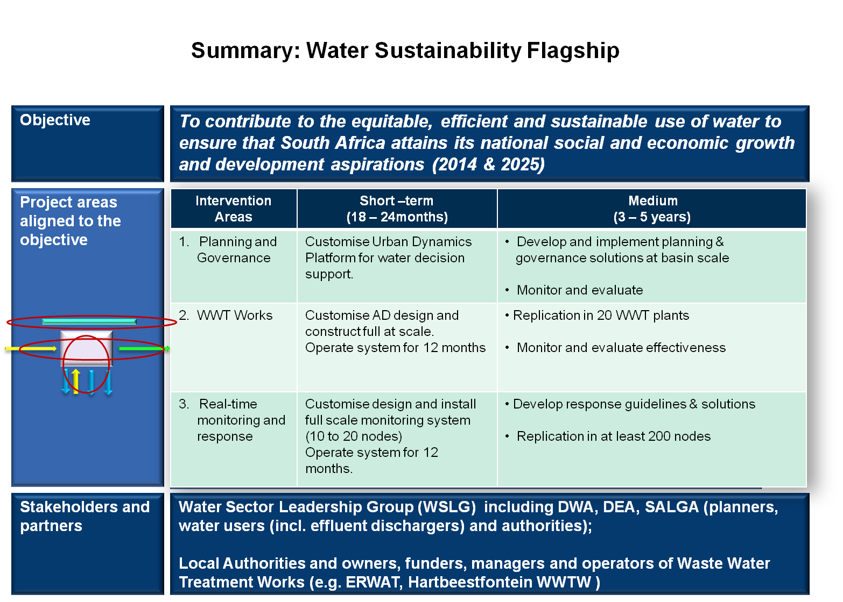

5.0 THE PROJECT DESCRIPTION
As described above, the key aspects of WSF is seen to be the fact that the D & I activities are packaged as an integrated solution aimed at national and even regional replication. The innovation therefore lies in:
- An integrated , multi-disciplinary solution, piloted in an Urban and Peri-urban environment that includes a predictive ability to provide current and future scenario-based insight into the quantity and composition of the effluent stream entering the waste water treatment system.
- The focus on increasing the longevity of aging WWT plants by rehabilitating and upgrading the Anaerobic Digester component that leads to compliance of the solid waste stream, an energy cost reduction via biogas production and the value add (and associated job creation) of producing safe compost for sale and use in community gardens.
- An efficient low cost integrated near real-time 1st level water quality monitoring system that allows for timely compliance evaluation and response at key nodes within the whole system to influence the Green Drop status of targeted municipalities.

The following criteria were defined for selecting the pilot sites where the technology demonstration would be focused:
- Integrated solution (co-location)
- Local community-level need or high-risk water problem
- Representative of national scale problem
- Co-funding available from local sources
- Ease of access to the pilot area by CSIR teams
- Current CSIR initiatives underway (co-locate)
  - Good relationship with key stakeholders
  - Current externally funded complementary projects

The application of the selection criteria resulted in the definition of a single integrated experiment piloted in two complementary locations, namely:
- The ERWAT managed Olifantsfontein WWTW located within an Urban setting in the upper Crocodile River catchment. The intervention would be focused on ‘Fit-for-use / purpose’ infrastructure improvement with a secondary aim for community job creation and household level impact via waste beneficiation and a community garden.
- The Sekhukhune District Municipality which is located in a Peri-Urban setting in the Upper Olifants River catchment where the focus will be on Green Drop status improvement.

The pilot sites are shown in the figures below.
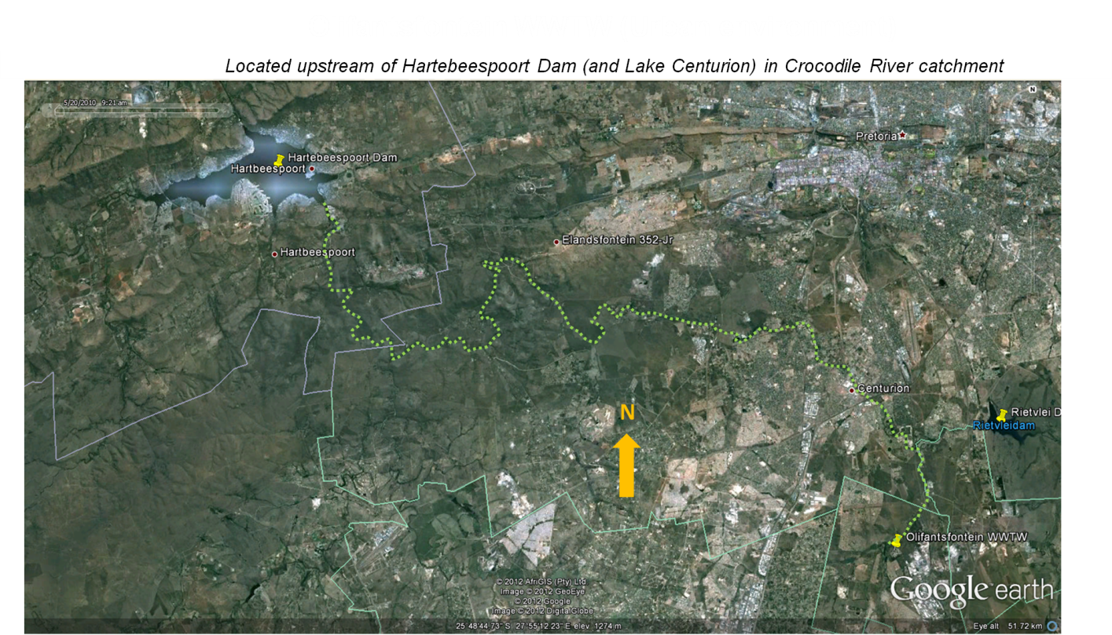

The Olifantsfontein Waste Water Treatment Works is located in an Urban environment in the Upper Crocodile River catchment
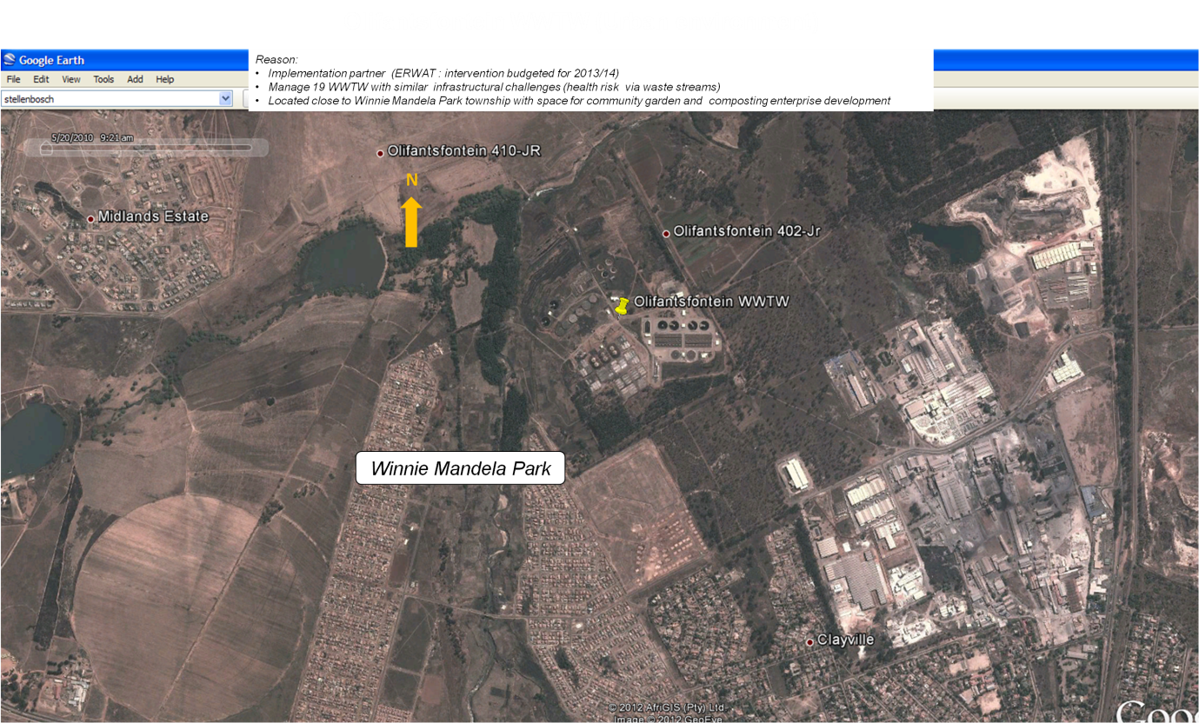

The Winnie Mandela Park community borders the Olifantsfontein WWTW, providing opportunities for job creation through waste beneficiation projects

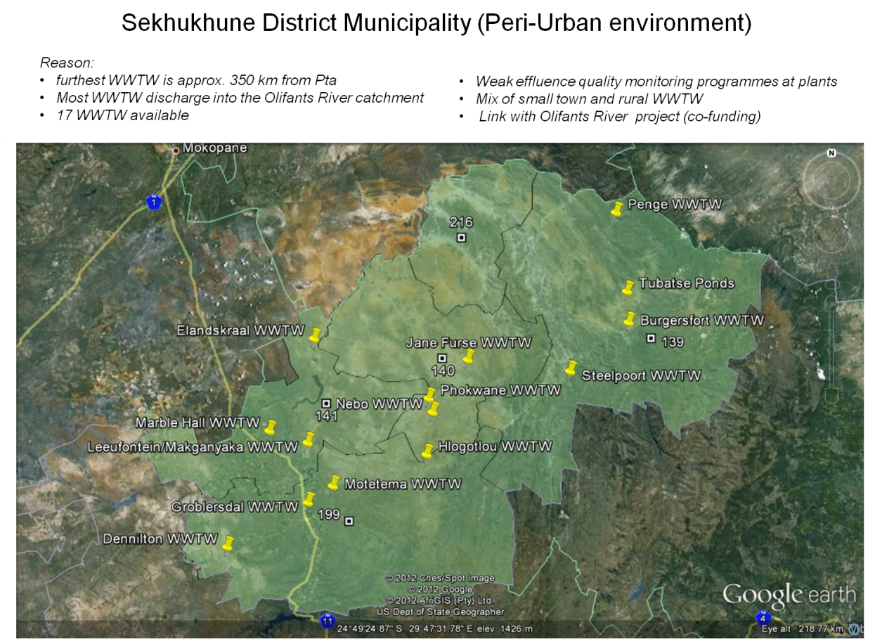

6.0 COMPONENTS OF THE INTEGRATED SOLUTION
A number of CSIR technology demonstrators that are aligned with the proposed integrated solution were identified. Three core technologies, all at TRL 5 or above were chosen as the core to the three interventions. These are briefly described below with the technical detail, along with the activities associated with the development and implementation of each are described in Appendices A, B and C of the full document (GWDMS#216950-Pta Gen).

The implementation of the technologies requires collaboration amongst researchers from BE, NRE, CAS, MSM, MDS and Meraka.

The overall objective of the integrative solution is to achieve water quantity, quality & efficiency at basin level, specifically related to wastewater treatment works (WWTWs).

Intervention Area 1: Planning and Governance

The Urban Growth Simulation Platform (UrbanSim) models spatially explicit patterns of urban growth over a 20-30 year period. Calibrating and adapting the modelling platform to facilitate the understanding and assessment of the impact of spatial planning and development on wastewater flows inflows to WWTW lies at the core of this intervention area. Existing knowledge and technologies will be integrated into a spatial (GIS) based risk platform to assess, prioritise and mitigate the impact of WWTWs on ecosystem and human health. This framework provides a good platform to facilitate discussions in a multi-party environment and facilitates a shared understanding of development patterns and trends and the forces that shape them, by providing the evidence required to inform rigorous and robust debate amongst the various agencies of the state.

The integrated solution will establish a platform to deliver different solutions at different levels, i.e. geographically (Plant, municipality, province, national), scales (small and large plants), governance (municipal, (inter)departmental, provincial, national), and temporal (short, medium and long term).

Intervention Area 2: Revitalising Waste Water Treatment Works

The CSIR has developed a new anaerobic digester (AD) technology package that improves the performance of anaerobic digestion considerably compared with existing processes and equipment used at WWT plants. The process is novel and consists of a two-stage, fully automated anaerobic digester that includes control of the critical parameters to optimize the process. In addition, it reduces the retention time of the sewage in the system by almost half, thus increasing the capacity of such a system significantly.

The CSIR, in collaboration with ERWAT (the WWT service provider to Ekurhuleni municipality), will pilot this innovative technology package at full scale at one of ERWAT’s WWTWs near

Intervention Area 3: Real-time water quality monitoring, assessment and response

The Green Drop certification programme in South Africa forms part of incentive-based regulation implemented by the Department of Water Affairs to identify and develop core competencies required in wastewater management. Compliance with the Green Drop certification programme will ensure that all Water Service Authorities are gradually and sustainably able to improve the level of wastewater management.

The Green Drop Certification program is specifically aimed at Waste Water Treatment Works (WWTW) and aims to ensure that WWTW continuously improve their operations so as not to impact negatively on the water bodies into which they discharge their end product. In order for plants to achieve Green Drop status, water quality monitoring is a key requirement.

The CSIR’s comprehensive solution looks to put in place systems, processes and procedures to complement those already in place and ensure the achievement and sustainability of Green Drop certification.

7.0 PROJECT DETAIL
As discussed above, the first part of the WSF is focused on short-term (1 to 2 years) focused intervention followed by a medium term (3 to 5 Year) period where the packaged integrated solution will be expanded to catchment scale and more components of the system (e.g. the water quantity aspects) will be addressed.

The detailed technical plan and associated Task Detail sheets for Year 1 (2012/13) are shown in Appendix D of the full project document (GWDMS#216950 Pta Gen). The work packages, resource allocations, milestones, deliverables, payment schedules and technical risk assessment for each of the Intervention Areas are all shown in the Task Detail Sheets for each of the work packages (or Intervention Areas.

Regular progress reviews will be held at specific stage-gates using the progress reports and information shown in the table presented in the following sections where Go, Redirect or Stop decisions will be made.

8.0 MEASURABLES (YEAR 1)

The project measurables for the WSF are shown as Quarterly stage-gate deliverables for the WSF, PG funded and Other co-funded projects in Table 1 along with their associated value.

Table 1: Stage Gate analysis for the WSF

Task | Quarter 1 |  |  | Quarter 2 |  |  | Quarter 3 |  |  | Quarter 4
IA1 PLANNING & GOVERNANCE (COORDINATED BY NRE) | Activity | Deliverable | Budget | Activity | Deliverable | Budget | Activity | Deliverable | Budget | Activity | Deliverable | Budget
WSF project: Planning and governance | • Assess case area conditions  • Develop detailed research plan  • Review key literature on pilot areas | Inception report | 825 | • Develop governance framework  • Collect and analyse available pilot site information and data  • Continue engagement with key stakeholders  • Assess available technologies for potential interventions  • Develop model for human settlements | Report on case areas, evaluation of technology options and stakeholders | 2150 | • Evaluate objectives  • Compare options and scenarios (informed by model) | Report on development trajectories and options | 2236 | • Develop and populating of risk matrix  • Finalise models  • Assess intervention options and prioritise  • Communicating findings (peer review and local stakeholders) | • Report on preferred intervention options • Feedback reports of stakeholder engagement; • Feedback from Peer rieviews | 1289
NRE: Aquabase, wetland index and water sustainability | Project scoping and planning | Detailed project plan | 355 | Analysis of available data and literature, data collection and stakeholder consultation | Report on data and literature synthesis, data collection and stakeholder consultation | 532 | Set up conceptual models for the study areas | Report on conceptual models | 532 | Develop models and ecological production functions | Report on the models and ecological production functions | 532
BE: Living lab application | Project scoping and planning | Detailed project plan | 182 | Desk Top Review of Urban Form Literature, Policies and Plans, Analysis of Simulation Results | Synthesis report on urban form literature, policies and plan and the results of the simulations | 273 | Develop a policy brief of the key findings in respect of alternative development scenarios | Policy brief available | 273 | Send out publications for peer review | Peer reviewed publications | 273
BIO: Water sustainability | Review of available literature | Report on literature review | 273 | Assessment of detection methods | Report on detection methods | 409 | Modify detection methods for the WSF | Report on recommended modified detection methods | 409 | Evaluation of detection methods | Report on evaluation of detection methods | 409
NRE: Coaltech sustainability and wetlands | Project scoping and planning | Detailed project plan | 655 | Stakeholder engagement and analysis of the cause-effect relationships in the study areas | Report on stakeholder engagement and cause-effect relationships | 982 | Evaluate and prioritise possible intervention options | Report on evaluation of possible intervention options | 982 | Implementation of selected options (continue into 2013/14) | Progress report on implementation of selected options | 982
BE: IPDM and GITMC | Project scoping and planning | Detailed project plan | 182 | Set up of customized model and validate for study areas. | Customized and validated model. | 273 | Determine the geographic scope | Progress report on geographic scope. | 273 | Evaluation of scenarios | Report on scenario evaluations | 273
IA2 INFRASTRUCTURE INTERVENTION | Activity | Deliverable |  | Activity | Deliverable |  | Activity | Deliverable |  | Activity | Deliverable
WSF Project: Infrastrucutre intervention, AD, community programme, electricity manufacturing | Site preparation and high level planning. | Signed MoA with ERWAT. Sign off by ERWAT on site location and nature of community programme. | 465 | Detailed planning | Detailed project plan based on first quarter activity for example site selection. | 1620 | Professional engineering design and procurement of equipment, contruction initiated | Final design, equipment delivered on site, first stage of construction completed | 3240 | Community programme initiated, baseline study complete, construction completion, system setup and commissioning | A working anaerobic digester system. Operational progress report. | 975
BE: Baseline study for impact assessment | N.A. | N.A. |  | Baseline study initiated | Progress report of baseline study | 900 | Continuation with baseline study | Baseline study completed |  | Report writing | Final PG report
BE: Development of conceptual design of enhanced aerobic solution | N.A. | N.A. | 200 | Literature survey | Report on proposed appraoch for developing aerobic solutions. |  | Conceptual design of solution. | Conceptual design. | 900 | Report writing | Final PG report
BE: DST project on AD:
Degritting of existing AD | N.A. |  | 0 | AD degritted |  | 320 | Complete
Purchase of equipment for upgrade | N.A. |  | 0 | Equipment purchased |  | 7507
Operation of plant and evaluation | N.A. |  | 0 | None |  | 0 | Operation and evaluation ongoing |  | 600
ERWAT maintenance and community programme | N.A. |  | 0 | Community programme initiated |  | 400 | Community programme ongoing |  | 600
IA3 REAL TIME MONITORING AND RESPONSE (COORDINATED BY CAS)
WSF Project: Real time monitoring system developemnt and installation | Preparation and equipment manufacturing, site inspections initiated. Integration of wide area alert system into existing platform. | 14 units ready for installation; functional wide area alert system | 2079 | Installations and water footprints complete; develop specifications for integrated open platform | Report on 14 site inspections, 14 installations and water footprint data; Open platform specifications document | 3812 | Development of Version 1 of next generation unit; continued monitoring of installations; Development of core modules of the IT infrastructure | Prototype of next generation unit (upgraded); monthly reports of water quality data; Progress report on module development; | 3082 | Continued monitoring of installations; development of next generation unit; Test and validate core models; Planning for phase-over to open standards and source information system | Final report on 14 installations; next generation manufacturing specification; Tested and validated core modules. Phase-over plan for IT system. | 3102
MSM: Project Management & field sampling (PG MSM) | Groundwork and lit survey | Report on literature survey | 150 | Field data collection | Report on field data | 300 | Organic probe prototype development | Organic probe prototype | 300 | Data collection and specification development for organic measurement | Specification for organic probe and measurement | 150
MER: Project Management (PG MERAKA) | Project management |  | 0 | Project management |  | 80 | Project management |  | 80 |  |  | 0
CAS: Systems, algorithms and rules | Site inspections | Report on site inspections | 1273 | Conceptual design completed | Conceptual design | 1909 | Evaluations | Report on findings from evaluations | 1909 | Market testing and validation | Final market ready design complete | 1909

9.0 FINANCIALS
The cashflow and funding split amongst units per Intervention area are shown in Table 2.

Table 2: WSF cashflow and funding split amongst Units per Intervention Area
WSF IA | UNIT | Q1 | Q2 | Q3 | Q4 | SUB-TOT | TOTAL
IA1 | NRE | 400 | 1042 | 1084 | 625 | 3151
 | BE | 425 | 1108 | 1152 | 664 | 3349 | 6500
IA2 | BE | 465 | 1620 | 3240 | 975 | 6300 | 6300
IA3 | MSM | 775 | 1250 | 1300 | 1258 | 4583
 | CAS | 1274 | 2472 | 1542 | 1384 | 6672
 | MERAKA | 30 | 90 | 240 | 460 | 820 | 12075
COORDINATION¹ | NRE | 400 | 600 | 600 | 640 | 2240 | 2240
CONTINGENCY² | TBC | 700 | 700 | 700 | 785 | 2885 | 2885
TOT |  | 4469 | 8882 | 9858 | 6791 | 30000 | 30000
Note 1: Coordination activities include regular review sessions and included the costs of organizing and facilitating interaction with stakeholders and the reference panel.
Note 2: The contingency pool is centrally controlled and funding releases will be agreed to through consensus during stage-gate review sessions. This implies that Units will share in the pool as the need arises.

The distribution of WSF funding to the various participating Units for each quarter in Year 1 is shown in Table 3.

Table 3: WSF Funding split amongst Units
UNIT | Q1 | Q2 | Q3 | Q4 | TOTAL
NRE | 800 | 1642 | 1684 | 1265 | 5391
BE | 890 | 2728 | 4392 | 1639 | 9649
MSM | 775 | 1250 | 1300 | 1258 | 4583
CAS | 1274 | 2472 | 1542 | 1384 | 6672
MERAKA | 30 | 90 | 240 | 460 | 820
CONTINGENCY¹ | 700 | 700 | 700 | 785 | 2885
TOTAL | 4469 | 8882 | 9858 | 6791 | 30000
Note 1: The contingency pool is centrally controlled and funding releases will be agreed to through consensus during stage-gate review sessions. This implies that Units will share in the pool as the need arises.

The cashflow associated with the expenditure for funds from the WSF, the PG portion and the Other co-funding for the first year is summarised in Table 4 below. The detailed breakdown of tasks and associated budget are provided in Appendices A, B, C and D with a summary provided in Appendix E of the full document.

Table 4: Cashflow for the WSF and associated co-funding sources
Description | 2013/14 |  |  |  |  |  |  |  |  |  |  |  |  |  | TOTALS
 | Q1 |  | Q2 |  |  |  |  | Q3 |  |  | Q4
 | May | Jun | Jul | Aug |  | Sep |  | Oct | Nov | Dec |  | Jan | Feb | Mar | WSF | PG | OTHER
WSF: 2012/13 CASHFLOW (Rx1000) | 2 110 | 2 359 | 2 239 | 3 214 |  | 3 429 |  | 3 189 | 3 855 | 2 814 |  | 2 194 | 2 976 | 1 621 | 30000
Cashflow sub-totals associated with Quarterly stage-gate deliverables | 4469 |  | 8882 |  |  |  |  | 9858 |  |  |  | 6791 |  |  | 30000
PG: 2012/13 CASHFLOW (Rx1000) | 455 | 1 005 | 1 025 |  | 1 035 |  | 735 | 735 | 635 | 525 |  | 505 | 505 | 455 |  | 7610
OTHER: 2012/13 CASHFLOW  (Rx1000) | 1 055 | 1 055 | 1 055 |  | 1 375 |  | 1 055 | 1 055 | 8 762 | 1 255 |  | 1 455 | 1 455 | 1 455 |  |  | 21027

The detailed cashflow from the WSF fund for the first year of the integrated project is shown in Appendix E and summarised in Table 5 below. Task Detail Sheets are provided in the full document for each of the project tasks (those funded under the WSF, PG and from external sources) for the IAs.

Table 5: Project Gantt Chart and cashflow breakdown per task (Year 1). (Amounts in R x 1000)
 | Task/Activity | 2013/14 |  |  |  |  |  |  |  |  |  |  |  | TOTALS | TOTALS | TOTALS
 | Description | May | Jun | Jul | Aug | Sep | Oct | Nov | Dec | Jan | Feb | Mar |  | WSF | PG | OTHER
1 | IA 1 PLANNING & GOVERNANCE (COORDINATED BY NRE) |  |  |  |  |  |  |  |  |  |  |  |  | 6 500 | 4 450 | 4 600
1.1 | Systems model: Cause-effect relationships | 350 | 350 | 350 | 350 | 350 | 350 | 336 |  |  |  |  |  | 2 436
1.2 | Establish integrated simulation platform setup and calibration |  |  | 200 | 300 | 400 | 400 | 400 | 200 | 400 | 386 |  |  | 2 686
1.3 | Consolidate and select intervention options |  |  |  |  |  | 100 | 200 | 100 | 200 | 115 |  |  | 715
1.4 | Project Management & reporting | 75 | 50 | 75 | 50 | 75 | 50 | 75 | 25 | 50 | 63 | 75 |  | 663
1.5 | NRE: Aquabase, wetland index and water sustainability | 177 | 177 | 177 | 177 | 177 | 177 | 177 | 177 | 177 | 177 | 177 |  |  | 1 950
1.6 | BE: Living lab application | 91 | 91 | 91 | 91 | 91 | 91 | 91 | 91 | 91 | 91 | 91 |  |  | 1 000
1.7 | BIO: Water sustainability | 136 | 136 | 136 | 136 | 136 | 136 | 136 | 136 | 136 | 136 | 136 |  |  | 1 500
1.8 | NRE: Coaltech sustainability and wetlands | 327 | 327 | 327 | 327 | 327 | 327 | 327 | 327 | 327 | 327 | 327 |  |  |  | 3 600
1.9 | BE: IPDM and urban dynamics laboratory | 91 | 91 | 91 | 91 | 91 | 91 | 91 | 91 | 91 | 91 | 91 |  |  |  | 1 000

2 | IA2 INFRASTRUCTURE INTERVENTION (COORDINATED BY BE) |  |  |  |  |  |  |  |  |  |  |  |  | 6 300 | 2 000 | 9 427
2.1 | Preparation of site at Olifantsfontein | 90 |  |  |  |  |  |  |  |  |  |  |  | 90
2.2 | Detailed planning | 100 | 100 | 100 |  |  |  |  |  |  |  |  |  | 300
2.3 | Preparation for and execution of community programme |  |  |  |  | 100 | 100 | 200 | 200 | 200 | 200 |  |  | 1 000
2.4 | Procurement of equipment |  | 50 | 30 | 25 | 25 | 50 |  |  |  |  |  |  | 180
2.5 | Installation of new equipment (mixing, heat exchange, piping, CHP generator, etc) |  |  |  | 100 | 100 | 50 | 50 | 100 |  |  |  |  | 400
2.6 | Design and construction of the second tank and gas storage |  |  |  |  | 690 | 600 | 600 | 690 |  |  |  |  | 2 580
2.7 | Installation of gas polishers / scrubbers to remove unwanted content from the biogas |  |  |  |  |  | 200 | 100 | 50 |  |  |  |  | 350
2.8 | Monitor and evaluate results (Baseline) |  | 100 | 100 | 100 |  |  |  | 100 | 100 | 100 | 100 |  | 700
2.9 | BE: Baseline study for impact assessment |  | 300 | 300 | 300 |  |  |  |  |  |  |  |  |  | 900
2.10 | BE: Development of conceptual design of enhanced aerobic solution |  | 200 | 200 | 200 | 200 | 200 | 100 |  |  |  |  |  |  | 1 100
2.11 | BE: DST project on AD:
2.11.1 | Degritting of existing AD |  |  |  | 320 |  |  |  |  |  |  |  |  |  |  | 320
2.11.2 | Purchase of equipment for upgrade |  |  |  |  |  |  | 7 507 |  |  |  |  |  |  |  | 7 507
2.11.3 | Operation of plant and evaluation |  |  |  |  |  |  |  |  | 200 | 200 | 200 | Ongoing |  |  | 600
2.12 | ERWAT maintenance and community programme |  |  |  |  |  |  | 200 | 200 | 200 | 200 | 200 |  |  |  | 1 000
2.13 | Project Management & reporting | 100 | 25 | 25 | 100 | 25 | 25 | 100 | 25 | 25 | 100 | 150 |  | 700

3 | IA3 REAL TIME MONITORING AND RESPONSE (CAS) |  |  |  |  |  |  |  |  |  |  |  |  | 12 075 | 1 160 | 7 000
3.1 | Pilot Sites Units Yr 1 | 125 | 250 | 200 | 200 | 100 | 100 | 100 | 100 | 60 | 60 | 60 |  | 1 355
3.2 | Integrate dissemination (alerting notification) subsystem bases on WAAS (MERAKA) | 20 | 10 | 10 | 10 | 10 | 10 |  |  |  |  |  |  | 70
3.3 | Design end-to-end integrated platform (MERAKA) |  |  |  | 30 | 30 | 30 |  |  |  |  |  |  | 90
3.4 | Configuration of Pilot Units Yr 1 |  | 25 |  | 25 |  | 25 |  | 25 |  |  |  |  | 100
3.5 | Governance - Site Inspections | 100 | 100 | 100 | 100 | 90 |  |  |  |  |  |  |  | 490
3.6 | Governance - Laboratory Testing |  | 80 | 40 | 40 | 40 | 40 | 40 | 40 | 40 | 40 | 42 |  | 442
3.7 | Governance - WWTW Assessments |  | 354 | 354 | 354 | 354 | 354 | 354 | 354 | 354 | 354 | 354 |  | 3 540
3.8 | Modelling & Algorithms |  | 100 | 100 | 100 | 100 | 100 | 100 |  |  |  |  |  | 600
3.9 | Hardware & Software |  | 80 | 80 | 80 | 80 | 80 | 80 | 80 | 80 | 80 | 80 |  | 800
3.10 | Implement near real time monitoring and simulation environment core infrastructure (MERAKA) |  |  |  |  |  |  | 100 | 100 | 90 |  |  |  | 290
3.11 | Implement integrated platform (MERAKA) |  |  |  |  |  |  |  |  | 70 | 150 | 150 |  | 370
3.12 | Next Generation | 150 | 250 | 250 | 250 | 250 | 300 | 300 | 400 | 450 | 400 | 228 |  | 3 228
3.13 | Project Management (WSF) | 100 | 25 | 25 | 100 | 25 | 25 | 100 | 25 | 25 | 100 | 150 |  | 700
3.14 | MSM: Project Management & field sampling (PG MSM) | 50 | 100 | 100 | 100 | 100 | 100 | 100 | 100 | 100 | 100 | 50 |  |  | 1 000
3.15 | MER: Project Management (PG MERAKA) |  |  | 20 | 30 | 30 | 30 | 30 | 20 |  |  |  |  |  | 160
3.16 | CAS: Systems, algorithms and rules | 636 | 636 | 636 | 636 | 636 | 636 | 636 | 636 | 636 | 636 | 636 |  |  |  | 7 000

4 | WSF PROGRAMME COORDINATION BY NRE |  |  |  |  |  |  |  |  |  |  |  |  | 5125 | 0 | 0
4.1 | Planning, Quality Control and Reporting | 200 | 200 | 200 | 200 | 200 | 200 | 200 | 200 | 200 | 200 | 240 |  | 2240 | 0 | 0
4.2 | Risk management (Contingency pool) | 700 |  |  | 700 |  |  | 700 |  |  | 785 |  |  | 2885 | 0 | 0
 | FUNDING TOTALS |  |  |  |  |  |  |  |  |  |  |  |  | 30 000 | 7 610 | 21 027

